FACULTY PROFILE
Name : Mr. Sudhir Ramchandra Dhongade
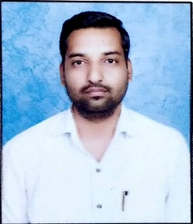
Qualification : M. A. SET.
Department : Political Science
Designation : Assistant Professor
Email : sudhirdhongade29@gmail.com
Teaching Experience : UG. 09 years

ACADEMIC CONTRIBUTIONS

Research Papers: 07

Research Area- Indian Political Process

